# Application front-end elements

Version 0.1

After login, a user is presented with the application main screen. The following elements will be reused on many of the screens.

For every width/height or relative width/height element we will strive to use a SCSS variables file, which we can modify. For instance, the width of the left menu portion will be 290px, we set this as a variable. The same goes for font-sizes etc.

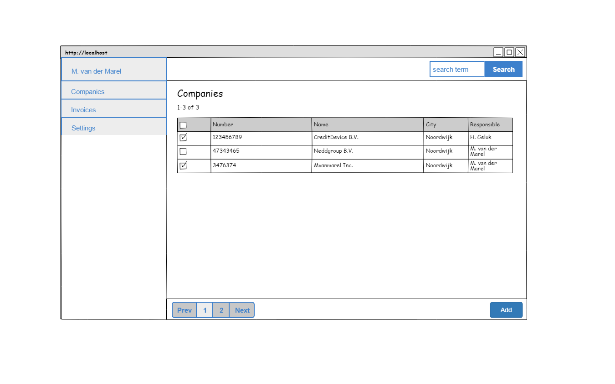

See the following live example of an application we have already produced:

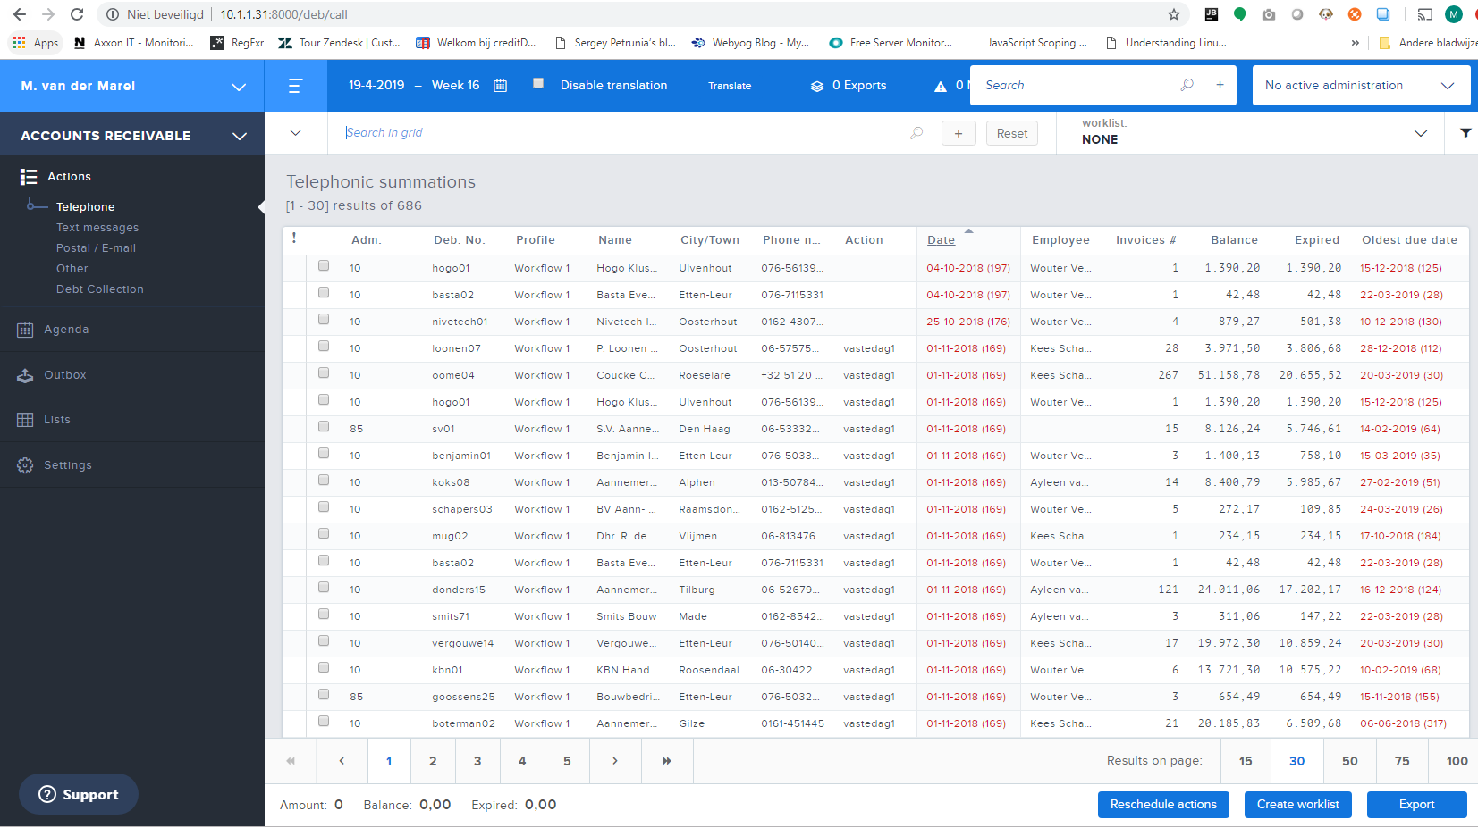

We take most parts of this example as a guide for the layout of our application. For now, you can ignore the exact colors. We will elaborate on that later.

## Main layout

We divide de main-layout into two sections (left and right in the above illustration). The entire grid stretches over the entire page, from left to right, from top to bottom. The left secion is always of the same size (for now the width will be 290px).

## Menu section

The menu section starts with a foldout menu user(preferences) menu, like this example, here the “user menu” is closed

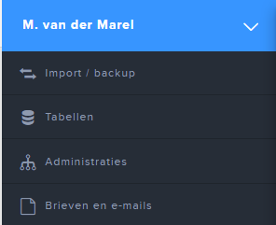

And open:

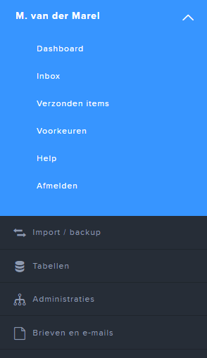

What we take from this example is the functional implementation: the menu opens as a foldout, has a certain amount of menuitems (exact items to be determined). The menu does not flow over the other menu, but pusses it down.

### Function menu

Below the user(preferences) menu there is the function-menu. Containing all the pages/functions a user can access from there. In the first example we have “companies”, “settings”. This will be extended over time with more!

The role of the user defines which items are available here.

## Top right section

The top right section contains a search bar, which is a generic search function, searching over companies, etc. The top section has room for more elements, which will be discussed later.

## Bottom section

The bottom section has room for a paginator and action buttons for within the page (add, save, reset etc.).

## Main content section

The main content will display the actual content of the action the user is doing. Like displaying a grid (in the first example). Every page has a title (h1) and optional a subtitle (h2). In case of a grid, the grid will have a title and as subtitle statistics of the selection (paginator state and count of rows).